**Intermediate Designs**

# **User Persona:**

**Name:** Muhammad Abdullah Khan  
 **Age:** 20  
 **Occupation:** University Student  
 **Location:** Islamabad, Pakistan  
 **Devices Used:** Android phone, Laptop

**Goals:**

* Order affordable meals quickly between classes.
* Get personalized restaurant suggestions.

**Frustrations:**

* Complicated checkout process.
* Long delivery times or no real-time tracking.

**Behaviors:**

* Uses app during short breaks.
* Prefers cash on delivery.
* Orders mostly from nearby restaurants.

**Favorite Apps:**

* Foodpanda, WhatsApp, TikTok.

# **User Flow:**

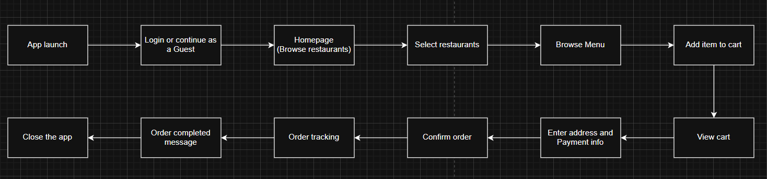

**Place Holders:**

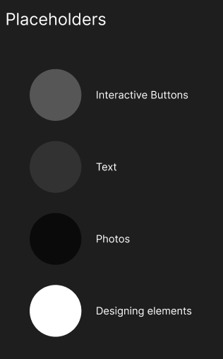

**3 Core Pages to Wireframe:**

**Page 1:**

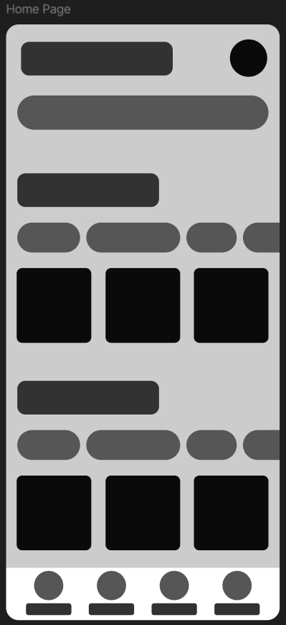

**Page 2:**

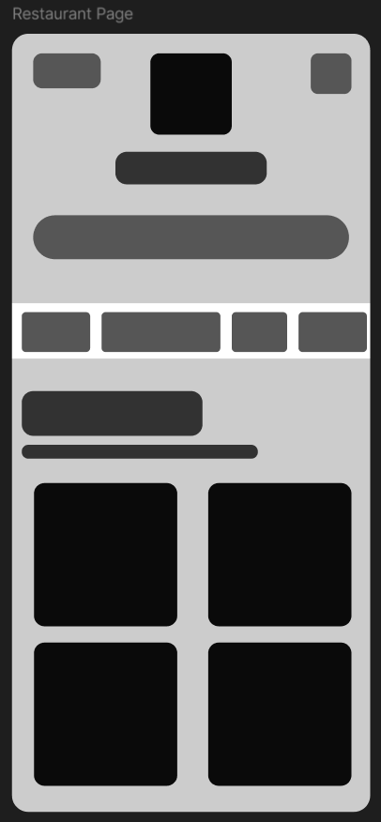

**Page 3:**

